Milestone 1 – Conceptual Model & Logical Relational Model

1. Introduction
This milestone presents the conceptual and logical modeling of the Recruitment Process Management System based on the business requirements outlined in the project proposal. The purpose of this milestone is to establish a clear, structured foundation for the database that supports candidates, interviews, job requisitions, offers, onboarding, and related recruitment activities.
The deliverables include: - An Enhanced Entity-Relationship (EER) Model (diagram referenced) - A UML Class Diagram (diagram referenced) - A complete Relational Model mapped from the conceptual design - Documentation of key attributes, cardinalities, constraints, and any unsupported business rules - Normalization justification

2. Business Requirements Summary(Condensed from project proposal)
The recruitment system supports the following processes:
- Managing candidates, their profiles, and sourcing information
- Tracking job requisitions created by clients
- Recording interviews and evaluation results by panel members
- Creating and managing offers for selected candidates
- Handling onboarding activities, background checks, and offer acceptance
- Capturing job requisition lifecycle and status history
These requirements define the entities and relationships modeled in the conceptual design.

3. Conceptual Model (EER Diagram)

3.1 Entities & Key Attributes
· Candidate: id (PK), name, email, phone, resume_url
· Job Requisition: id (PK), title, status, client_id
· Interview: id (PK), candidate_id, job_requisition_id, scheduled_at, status
· Evaluation: id (PK), interview_id, panel_member_id, score, decision
· Offer: id (PK), candidate_id, job_requisition_id, status, salary, offered_at
· Onboarding: id (PK), offer_id, activity_name, status
· Client: id (PK), name, industry
· Sourcing Activity: id (PK), recruiter_id, candidate_id, job_requisition_id

3.2 Relationships & Cardinalities
- Candidate applies to Job Requisition (1–M via Sourcing Activity)
- Job Requisition belongs to Client (M–1)
- Candidate attends Interviews (1–M)
- Interview has Evaluations (1–M)
- Candidate receives Offers (1–M)
- Offer initiates Onboarding (1–M)
- Recruiter sources Candidates (1–M)

3.3 Unsupported / Non-enforceable Constraints
- Certain workflow constraints (e.g., “evaluation must follow interview”) cannot be enforced at schema level.
- Multi-step business rules (like onboarding sequence) require application logic.

4. UML Class Diagram
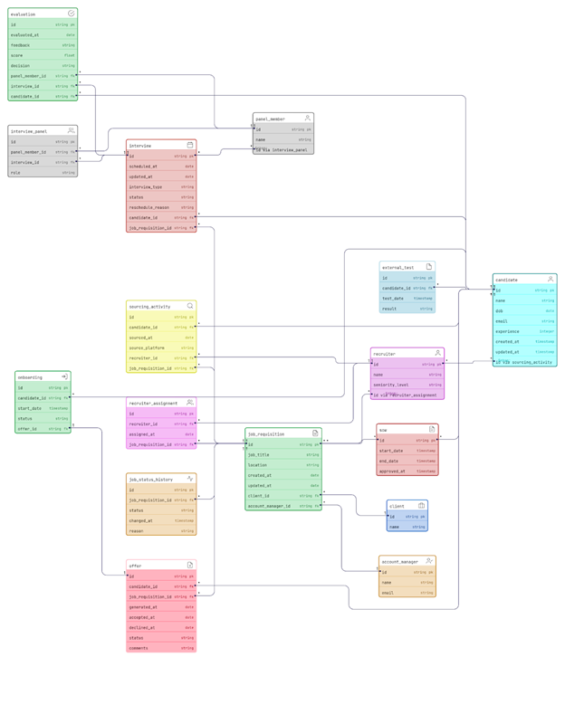
A UML class diagram is included to complement the EER diagram and represents:
- Attributes
- Multiplicities
- Associations
- Optional/mandatory relationships
This provides a software engineering perspective on system structure.

5. Logical Model (Relational Schema)
Below is the complete mapping from conceptual to logical relational model.
candidate(id, name, dob, email, experience, created_at, updated_at)
external_test(id, candidate_id, test_date, result)
recruiter(id, name, seniority_level)
recruiter_assignment(id, recruiter_id, assigned_at, job_requisition_id)
sourcing_activity(id, candidate_id, sourced_at, source_platform, recruiter_id, job_requisition_id)
job_requisition(id, job_title, location, created_at, updated_at, client_id, account_manager_id)
job_status_history(id, job_requisition_id, status, changed_at, reason)
offer(id, candidate_id, job_requisition_id, generated_at, accepted_at, declined_at, status, comments)
onboarding(id, candidate_id, start_date, status, offer_id)
client(id, name)
account_manager(id, name, email)
sow(id, job_requisition_id, start_date, end_date, approved_at)
interview(id, scheduled_at, updated_at, interview_type, status, reschedule_reason, candidate_id, job_requisition_id)
panel_member(id, name)
interview_panel(id, panel_member_id, interview_id, role)
evaluation(id, evaluated_at, feedback, score, decision, panel_member_id, interview_id, candidate_id)
5.1 Relations, Primary Keys, and Foreign Keys
· Candidate(id PK, name, dob, email, phone, resume_url)
· Client(id PK, name, industry)
· Job_Requisition(id PK, job_title, job_description, status, client_id FK→Client.id)
· Sourcing_Activity(id PK, recruiter_id FK→Recruiter.id, candidate_id FK→Candidate.id, job_requisition_id FK→Job_Requisition.id)
· Interview(id PK, candidate_id FK→Candidate.id, job_requisition_id FK→Job_Requisition.id, scheduled_at, status)
· Evaluation(id PK, interview_id FK→Interview.id, panel_member_id FK→Panel_Member.id, score, decision)
· Offer(id PK, candidate_id FK→Candidate.id, job_requisition_id FK→Job_Requisition.id, status, salary, offered_at)
· Onboarding(id PK, offer_id FK→Offer.id, activity_name, activity_status)
· Recruiter(id PK, name, email)
· Panel_Member(id PK, name, designation)

5.2 Normalization Summary
The normalization review of the Recruitment Workflow Database demonstrates a systematic evaluation of 1NF, 2NF, and 3NF compliance across all schema tables. The analysis confirms that each table is fully normalized, with no partial or transitive dependencies, ensuring a robust and efficient design for relational querying and future scalability.

1NF: First Normal Form Assessment
A table is in 1NF if:
All attributes are atomic (no arrays, repeating groups)
Each row-column intersection contains a single value
Rows are unique, with a defined primary key
Evaluations:
- All attributes in each table are single-valued and atomic.
- There are no repeating groups or array-like fields.
- Each table has a primary key; interview_panel uses a composite key (panel_member_id, interview_id), which is appropriate for many-to-many relationships.
Conclusion:
All tables in the schema satisfy 1NF.

2NF: Second Normal Form Assessment
A table is in 2NF if:
It is in 1NF
Every non-key attribute depends on the whole primary key (no partial dependencies)
This primarily affects tables with composite primary keys
Evaluations:
Table | Composite PK | 2NF Status
interview_panel | (panel_member_id, interview_id) | No partial dependencies; 2NF OK
recruiter_assignment | No (single PK: id) | 2NF OK
job_status_history | No (single PK: id) | 2NF OK
sourcing_activity | No (single PK: id) | 2NF OK
Conclusion:
All tables satisfy 2NF; composite key tables do not have partial dependencies.

3NF: Third Normal Form Assessment
A table is in 3NF if:
It is in 2NF
No transitive dependencies (i.e., non-key attributes do not depend on other non-key attributes)
Table-by-table summary:
Table | Status | Reasoning
candidate | In 3NF | All attributes depend on candidate_id
recruiter | in 3NF | All attributes depend on recruiter_id
job_requisition | in 3NF | All depend on job_requisition_id
client | in 3NF | Only client_id
account_manager | in 3NF | Only account_manager_id
interview | in 3NF | Only interview_id
panel_member | in 3NF | Only panel_member_id
external_test | in 3NF | Only external_test_id
evaluation | in 3NF | Only evaluation_id
offer | in 3NF | Only offer_id
onboarding | in 3NF | Only onboarding_id
sourcing_activity | in 3NF | Only sourcing_activity_id
recruiter_assignment | in 3NF | Only recruiter_assignment_id
job_status_history | in 3NF | Only job_status_history_id
sow | in 3NF | Only sow_id
Conclusion:
No tables have transitive dependencies; all tables are fully normalized to 3NF.
Summary:
The Recruitment Workflow Database schema is fully normalized, conforming to 1NF, 2NF, and 3NF. This ensures efficient data storage, eliminates update anomalies, and enables scalable, flexible querying.

6. Constraints and Cardinality Documentation
- Mandatory FK constraints enforce referential integrity.
- Some cardinalities (e.g., exact number of interviews per candidate) cannot be enforced in SQL/NoSQL.

